BAEL PICTURES

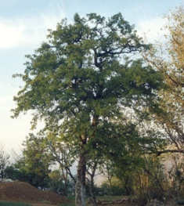

A wild bael tree

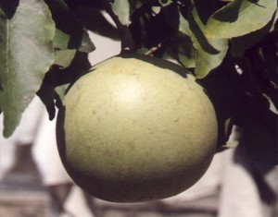

Bael fruit

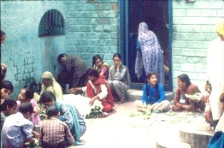

Bael leaves being sold at the biggest Shiva temple of Mandi

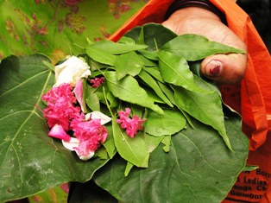

Bael leaves and flowers ready to be offered to Lord Shiva

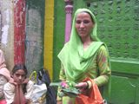

A devotee

