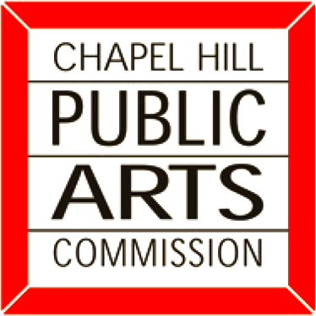

MEMBERSHIP as of February 2012

Christopher Beacham
259 Sweet Bay Place
Carrboro, NC 27510
(h) 260-6297 (w) 933-6699
cbeacham0204@gmail.com
(2013) replacement term ends
Rebecca Brenner
700 Bolinwood Drive, Apt. 40B
Chapel Hill, NC 27514
(c) 923-8645
rbrenner@email.unc.edu
(2013) replacement term ends
Daniel Cefalo
1404 Brigham Road
Chapel Hill, NC 27517
(h) 240-7478 (w) 305-219-9922
cefalobuilt@gmail.com
(2012) replacement term ends
Andrew Gerschutz
5504 Hideaway Drive
Chapel Hill, NC 27516
(h) 270-4807 (w) 286-8165
andy.gerschutz@gmail.com
(2014) 1st term ends
Lisa Goldstein
212 Collinson Drive
Chapel Hill, NC 27514
(h) 967-7304 (c) 740-3662
lisapg@nc.rr.com
(2012) replacement term ends
Nancy Kitterman, Chair
1908 South Lakeshore Drive
Chapel Hill, NC 27516
(h) 919-370-9582
Nancy.Kitterman@MadisonMarquette.com
(2013) replacement term ends

Zachary Kohn
80 Maxwell Road
Chapel Hill, NC 27517
(h) 301-385-2560
zkohn@email.unc.edu
(2014) 1st term ends

Alexander McSpadden
508 ½ North St.
Chapel Hill, NC 27514
(h) 301-602-3683
amcspadden@gmail.com
(2014) 1st term ends

Scott Radway, Vice Chair
505 Westminster Drive
Chapel Hill, NC 27514
(h) 942-5929 (w) 880-5579
scott@radwaydesign.com
(2013) 2nd term ends
Hudson Vincent
216 Nunn Lane
Chapel Hill, NC 27516
(c) 770-312-0055
rhvincent@gmail.com
(2012) replacement term ends
Jennifer Wales
9 Brandon Road
Chapel Hill, NC 27157
(c) 347-645-8020
jawales@aol.com
(2014) 1st term ends

Town Council Liaison

Lee Storrow
LeeStorrow.CH@gmail.com
(2014) 1st term ends

Public and Cultural Arts Office Staff

Jeffrey York, Public Art Administrator
200 Plant Road
Chapel Hill, NC 27514
(w) 968-2750 (c) 450-5338
jyork@townofchapelhill.org

Steve Wright, Public Art Coordinator
200 Plant Road
Chapel Hill, NC 27514
(w) 968-2749 (c) 260-2509
swright@townofchapelhill.org

