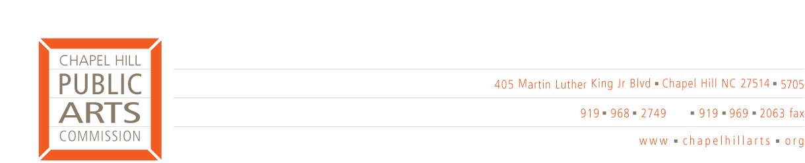

2011-12 MEETING DATES

Chapel Hill Public Arts Commission meetings:

The CHPAC meets on the 2nd Wednesday of each month
5:30 p.m. at 523 East Franklin Street, Chapel Hill, NC 27514

2011
July 13
No Meeting
September 14

October 12
November 9
December 14
January 11
February 8
March 14
April 11
May 9
June 13

Commission meeting dates, agendas and minutes may be found on the Town’s on-line Events Calendar by clicking on the CHPAC Meeting link on the second Wednesday of the month. Visit http://www.townofchapelhill.org/index.aspx?page=15

