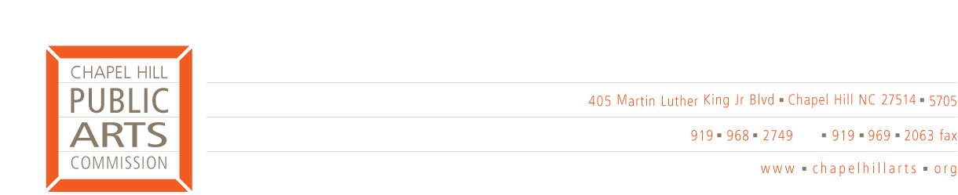

2011 MEETING DATES

Chapel Hill Public Arts Commission meetings:

The CHPAC meets on the 2nd Wednesday of each month
5:30 p.m. at 523 East Franklin Street, Chapel Hill, NC 27514

2011

January 12
February 9
March 9
April 13
May 11
June 8

July 13
August 10
September 14
October 12
November 9
December 14

Commission meeting dates, agendas and minutes may be found on the Town’s on-line Events Calendar by clicking on the CHPAC Meeting link on the second Wednesday of the month. Visit http://www.townofchapelhill.org/index.aspx?page=15

Program Committee meetings:

To be determined by individual committees.

