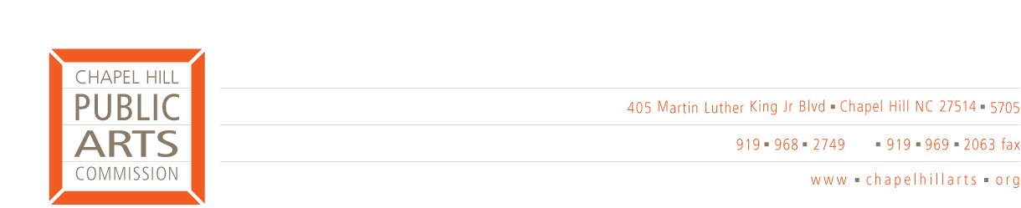

MEMORANDUM

TO: Chapel Hill Town Council
FROM: Chapel Hill Public Arts Commission
RE: Artist Selection Policies for Municipal Art Programming
DATE: April 1, 2008

In response to the Chapel Hill Town Council’s February 25, 2008 petition requesting information on policies and procedures governing selection for the Town’s municipal art programming, the Chapel Hill Public Arts Commission offers this memorandum and the attached documents: the Percent for Art Ordinance (2002), the Percent for Art Resolution and the Percent for Art Program Implementation Procedures.

How much control does the Town currently have over public art programming?
The Town has almost total control over the programming and activity of the Chapel Hill Public Arts Commission (CHPAC) and will continue to do so after CHPAC is brought under Town management upon the hire of the Public Art Administrator this spring. Since CHPAC meetings are open to the public and Town Council deliberations are public, there are also many opportunities for citizens to voice opinions.
- Although an independent 501c3, CHPAC follows the rules and regulations contained in the Town Procedures Manual; CHPAC Board Members are appointed by the Town Council.
- Town appropriations for public art are made in response to a program proposal and corresponding budget request submitted annually by CHPAC and discussed and approved by Town Council. Funds under the approved budget are released every other month in response to CHPAC invoices to the Town.
- CHPAC is held accountable to the Town Council for its expenditures. Financial reports are submitted to the Town Finance Office quarterly throughout the year. A formal report, including a financial report is submitted annually to the Town Finance Office at the end of each fiscal year. CHPAC is also subject to audits like other Town departments

How are Percent-for-Art projects managed and artists selected?
- Percent-for-Art (PFA) projects are managed in accordance with the directives of the Percent-for-Art Ordinance, which was adopted by Town Council in 2002.
- The Town decides which public development projects qualify for one percent for art and each project must be approved by the Town Council. CHPAC then works with Town officials and Town staff to draft plans for the PFA projects.
- CHPAC prepares a call to artists, which is circulated to local artists and nationwide.
- Artists are selected by the Public Art Review Committee (which comprises local arts professionals, a representative of CHPAC, elected officials, Town staff and others) and recommended for the approval of the Town Council at its public meetings.
- Implementation is managed jointly with the Town.
- All PFA finances stay under the control of the Town and are not transferred to CHPAC.

Should calls for Percent-for-Art proposals be restricted to local artists?
- The principal criteria in the selection of public artists for projects are artistic excellence and the ability to realize a successful project. These criteria respect the interests of Chapel Hill’s citizens as well as its artists.
- Opportunities for our local artists would be severely limited if other U.S. towns and cities had a policy of restricting eligibility to their local artists.
- Public artists, who undertake major projects integral to new developments, require skills and experience not generally found in studio artists or even sculptors. These include experience and knowledge of architecture, landscaping and so-on, since the public art process involves extensive interaction with architects, engineers, contractors and others whose needs must be met by the artist. This experience is characteristic of the public artists like Larry Kirkland, Mikyoung Kim and Janet Echelman who have been awarded contracts for large projects in Chapel Hill. Few North Carolina artists qualify in this way and few have acquired the teams needed to implement these complex projects from conception through installation.
- These essential elements of success may explain why, of the 67 applications for the Art Area II commission for the Lot 5 project, only three applicants were from North Carolina. North Carolina artists had been strongly encouraged to apply and the RFQ was circulated through local, regional, and state-wide artists’ networks in North Carolina. Of the four finalists for Lot 5’s Art Area II commission, one was from Chapel Hill.

How does CHPAC ‘empower’ local artists?
- Of a total Town appropriation of $150,000 for fiscal year 2007/2008, approximately 85 percent is spent in the Chapel Hill/Triangle area
- Most CHPAC programs involve local artists (Chapel Hill/Orange County/Triangle area)
- Artist in Residence (100 percent)
- Community Art Project (100 percent)
- Exhibitions (60 percent Chapel Hill/Orange County/Triangle; 40 percent regional or national). In the past two years 42 Orange County artists were given feature exhibitions by CHPAC. The Orange County Artist Guild’s total membership is 117 artists, which suggests that the CHPAC has recently showcased one third of the county’s artists.
- Black History Month (100 percent)
- Sculpture Visions (78 percent NC; 22 percent regional or national)
- Percent for Art: The Town has eight PFA projects that have either been completed or are in various stages of development. Of these eight commissions, three were created by local artists.
- By mobilizing additional citizen volunteers and connecting artists with communities CHPAC has a catalytic effect on the enrichment of the community through art

Is Chapel Hill’s public art cost effective?
- CHPAC Board Members are volunteers and commit long hours outside meetings to create and manage CHPAC programs
- The Commission mobilizes additional volunteers from the community to assist in managing the Community Art and Artist-in-Residence programs
- Public art is widely recognized as an economic tool that contributes to making a town an attractive venue for businesses.

