CHAPEL HILL PUBLIC ART CONTEXTUAL PLAN

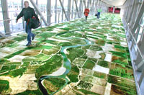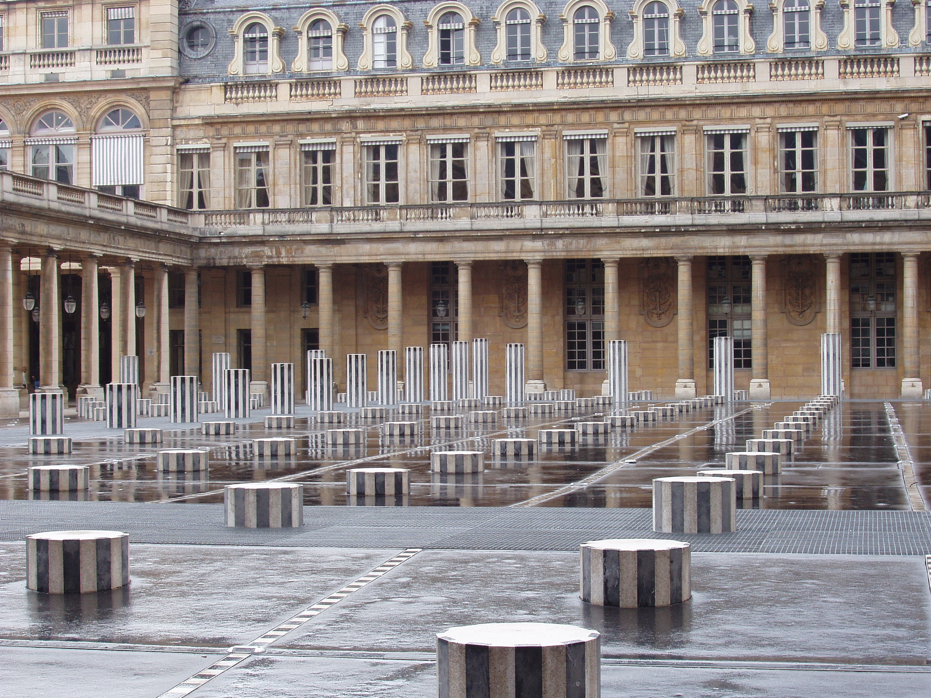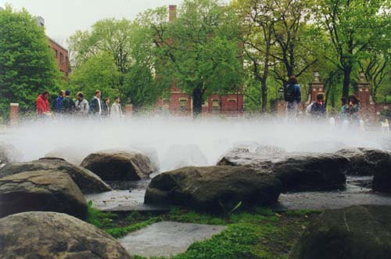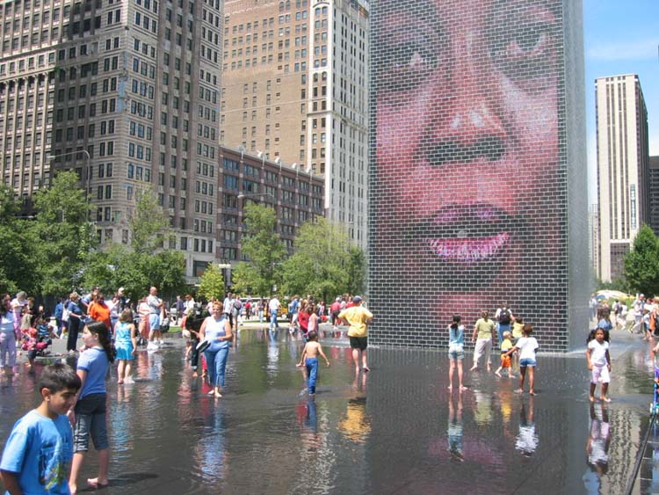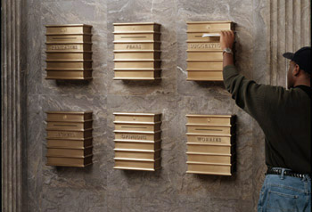

AN APPENDIX TO THE TOWN’S COMPREHENSIVE PLAN

SUBMITTED BY THE:
CHAPEL HILL PUBLIC ARTS COMMISSION

PREPARED BY:
GAIL M. GOLDMAN ASSOCIATES

The Chapel Hill Public Art Contextual Plan was made possible through funding from the
Town of Chapel Hill and North Carolina Arts Council

