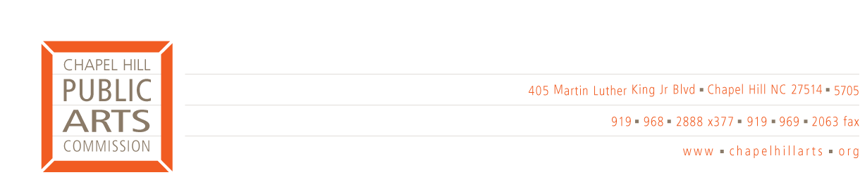
COMMITTEE REPORT

Committee name: Artists-in-Residence

Date submitted: September 12, 2005

Highlights for the upcoming month: Schedule meeting to launch pilot with one school in Spring 06.

Last meeting date: Friday, September 9th @ 1:00 pm

Attendees: Debbie Hepp, Kate Flory, Pam Pease, Steve Wright, Hollie Taylor

Summary of discussion(s): We have had two meetings of the Artists-in-Residence committee.
We discussed ideas on launching a program that would bring artist-designed projects to elementary schools in the Chapel Hill-Carrboro communities. This program would provide an opportunity for school children, parent docents and art teachers to be introduced to the work of professional artists in our community, and to gain hands-on experience in creating a project of their design. The program would culminate in an exhibit featuring the work created by the students at a local museum or gallery.

This program would:
• Increase awareness of the arts throughout our community
• Enhance the art curriculum in our schools by offering experiences that might not typically be available in
a school setting
• Involve local artists in sharing their unique vision, and in seeing an exhibit of art inspired by their work

We have obtained a manual from the Art at Your Fingertips program (which has been running successfully in the Los Angeles area for 30 years) which will help us evaluate how a program like this could be adapted by the CHPAC in conjunction with the CHCCS. Our plan is to do a pilot program in Spring 2006 with the third grade classes at one school, and if successful, to circulate a Call to Artists for projects to be implemented in Fall 2006.

Action items for full commission to consider: None

Future action items: Prepare presentation outlining goals and benefits of this program for conversations with selected art teachers to assess interest.

Next meeting scheduled: TBD

Submitted by: Pam Pease

