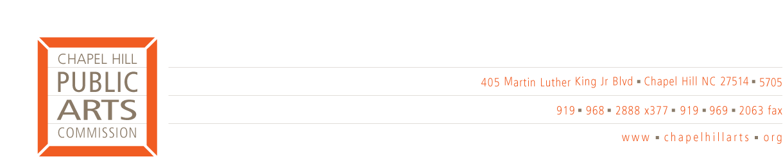

Monthly Meeting
Wednesday, September 14 5:00 pm
Town Hall – 1st Floor Conference Room

AGENDA

- Call to Order

- Announcements (20 minutes)
Animal Scramble update
FestiFall update
North Carolina Public Art Administrator’s Roundtable

- Approval of Minutes (5 minutes)
August 2005

- Treasurer’s Report (5 minutes)

- CHPAC Operating Procedures (20 minutes)

- Artist in Residence Update (15 minutes)

- Committee Action Items (10 minutes)

- New Business (5 minutes)

- Personnel Issues (30 minutes)

- Public Art Flash (10 minutes)

- Adjournment

