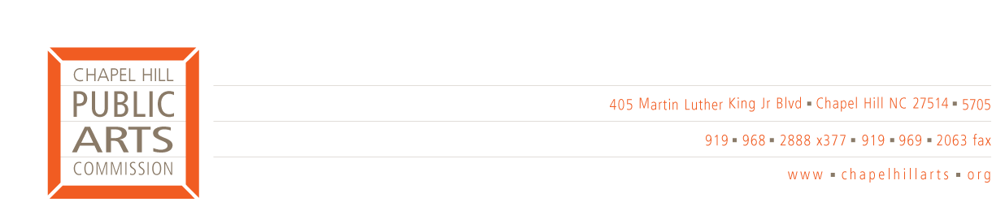
COMMITTEE REPORT

Committee name: Executive Committee

Date submitted: 9/9/05

Highlights for the upcoming month:

Last meeting date: 9/8/05

Attendees: Jeff Cohen, Dick Robinson, Jen Horney, Debbie Hepp, Kate Flory (staff)

Summary of discussion(s):
Reviewed Operating Procedures Document prior to presenting to Board for approval

Contextual Plan Update: RFP mailed out, Deadline: 9/16. Discussed options for selection process. Kate will discuss with Janet and follow-up with Executive Committee.

Reviewed Logo Use policy by artists and arts organizations. Decided to strengthen language regarding use and added requirement of review of artist’s or organization’s publicity materials prior to publication.

Reviewed Agenda for upcoming board meeting

Discussed Citizen letter regarding Sculpture Visions piece at Community Center and potential hazard. A letter will be sent to citizen and a caution sign (with language reviewed by Dick) will be placed next to piece. The piece will not be altered in any way.

Action items for full commission to consider:

Future action items:

Next meeting scheduled: 10/6/05

Submitted by: Jeff Cohen

