AGENDA #7
MEMORANDUM

TO: Mayor and Town Council

FROM: W. Calvin Horton, Town Manager

SUBJECT: Recommended 2005 Downtown Improvement Projects

DATE: April 11, 2005
REISSUED: April 25, 2005

Adoption of the attached resolutions would authorize the Town Manager to:

1) Submit a Specialty Lighting Request to Duke Power Company for the installation of four mast arm traffic signal poles at the intersection of Franklin and Columbia Streets and two mast arm signal poles at the intersection of East Franklin Street and Porthole Alley, at an estimated cost of approximately $230,000, including design fees and upgraded crosswalks;

2) Develop working drawings for Streetscape improvements on the south side of the 100 and 200 blocks of West Franklin Street adjacent to University Square, discuss plans with property owners and merchants, utilize $240,000 of the 2003 Streetscape bond funds, and begin construction in May 2005;

3) Submit a Specialty Lighting Request to Duke Power Company for the installation of custom street and pedestrian lighting on the south side of the 500 and 600 blocks of West Franklin Street where other Streetscape improvements including the underground duct bank necessary to serve the proposed light fixtures, have already been completed. The cost of the lighting improvements is estimated to be approximately $60,000.

BACKGROUND

On November 22, 1993, the Town Council approved the Downtown Streetscape Master Plan. Since that time, construction projects totaling 3,168 linear feet have been completed by Public Works crews. In addition to improvements constructed by Public Works crews, private developers and Orange County have installed several sections of improvements in conjunction with new construction and the renovation of existing downtown buildings. In addition, 34 new custom street and pedestrian light fixtures have been or are in the process of being installed. A map of the Streetscape study area indicating where improvements have been completed is included in the attachments (Attachment 1).

In 1996, $1,000,000 in Streets and Sidewalks bonds were approved for Streetscape improvements. Of that total, approximately $35,000 remains unencumbered.

In November of 2003, a bond referendum was approved that included authorization of $2 million for future Streetscape projects, including lighting. The initial sale of bonds generated $500,000 for Streetscape improvements. One percent for public art has been deducted from the total and reallocated for that purpose leaving $495,000 available. Combined with the 1996 current balance, the total available for downtown improvements is $530,000.

DISCUSSION

Each year prior to the summer construction season, Town staff has provided the Council with proposals detailing different locations where Streetscape improvements are needed and could be implemented using available funds. This year’s report presents two proposals for lighting and traffic signal improvements where the necessary underground duct bank is in place to service these improvements, as well as one proposal for a sidewalk reconstruction project utilizing in-house labor during the summer construction season, between the University’s spring commencement and the beginning of the fall term in mid-August. The total cost of the two lighting and traffic signal improvement projects is estimated to be $290,000. The cost of the sidewalk reconstruction project, utilizing in-house labor, is estimated to be $240,000. Implementing all of these improvements would encumber all of the $530,000 in currently available funds. Alternatively, the Council could choose to retain some of the available funds and not authorize the completion of one or more of these projects at this time.

This year, it could be possible for the Town to pursue more than one project simultaneously given that adequate funding is available and Town labor would primarily be required only for the sidewalk reconstruction project. Lighting and mast arm signal pole improvements are installed by contractors with only limited assistance by Public Works staff. The following diagrams illustrate the design of the proposed streetlights, pedestrian lights and mast arm signal poles.
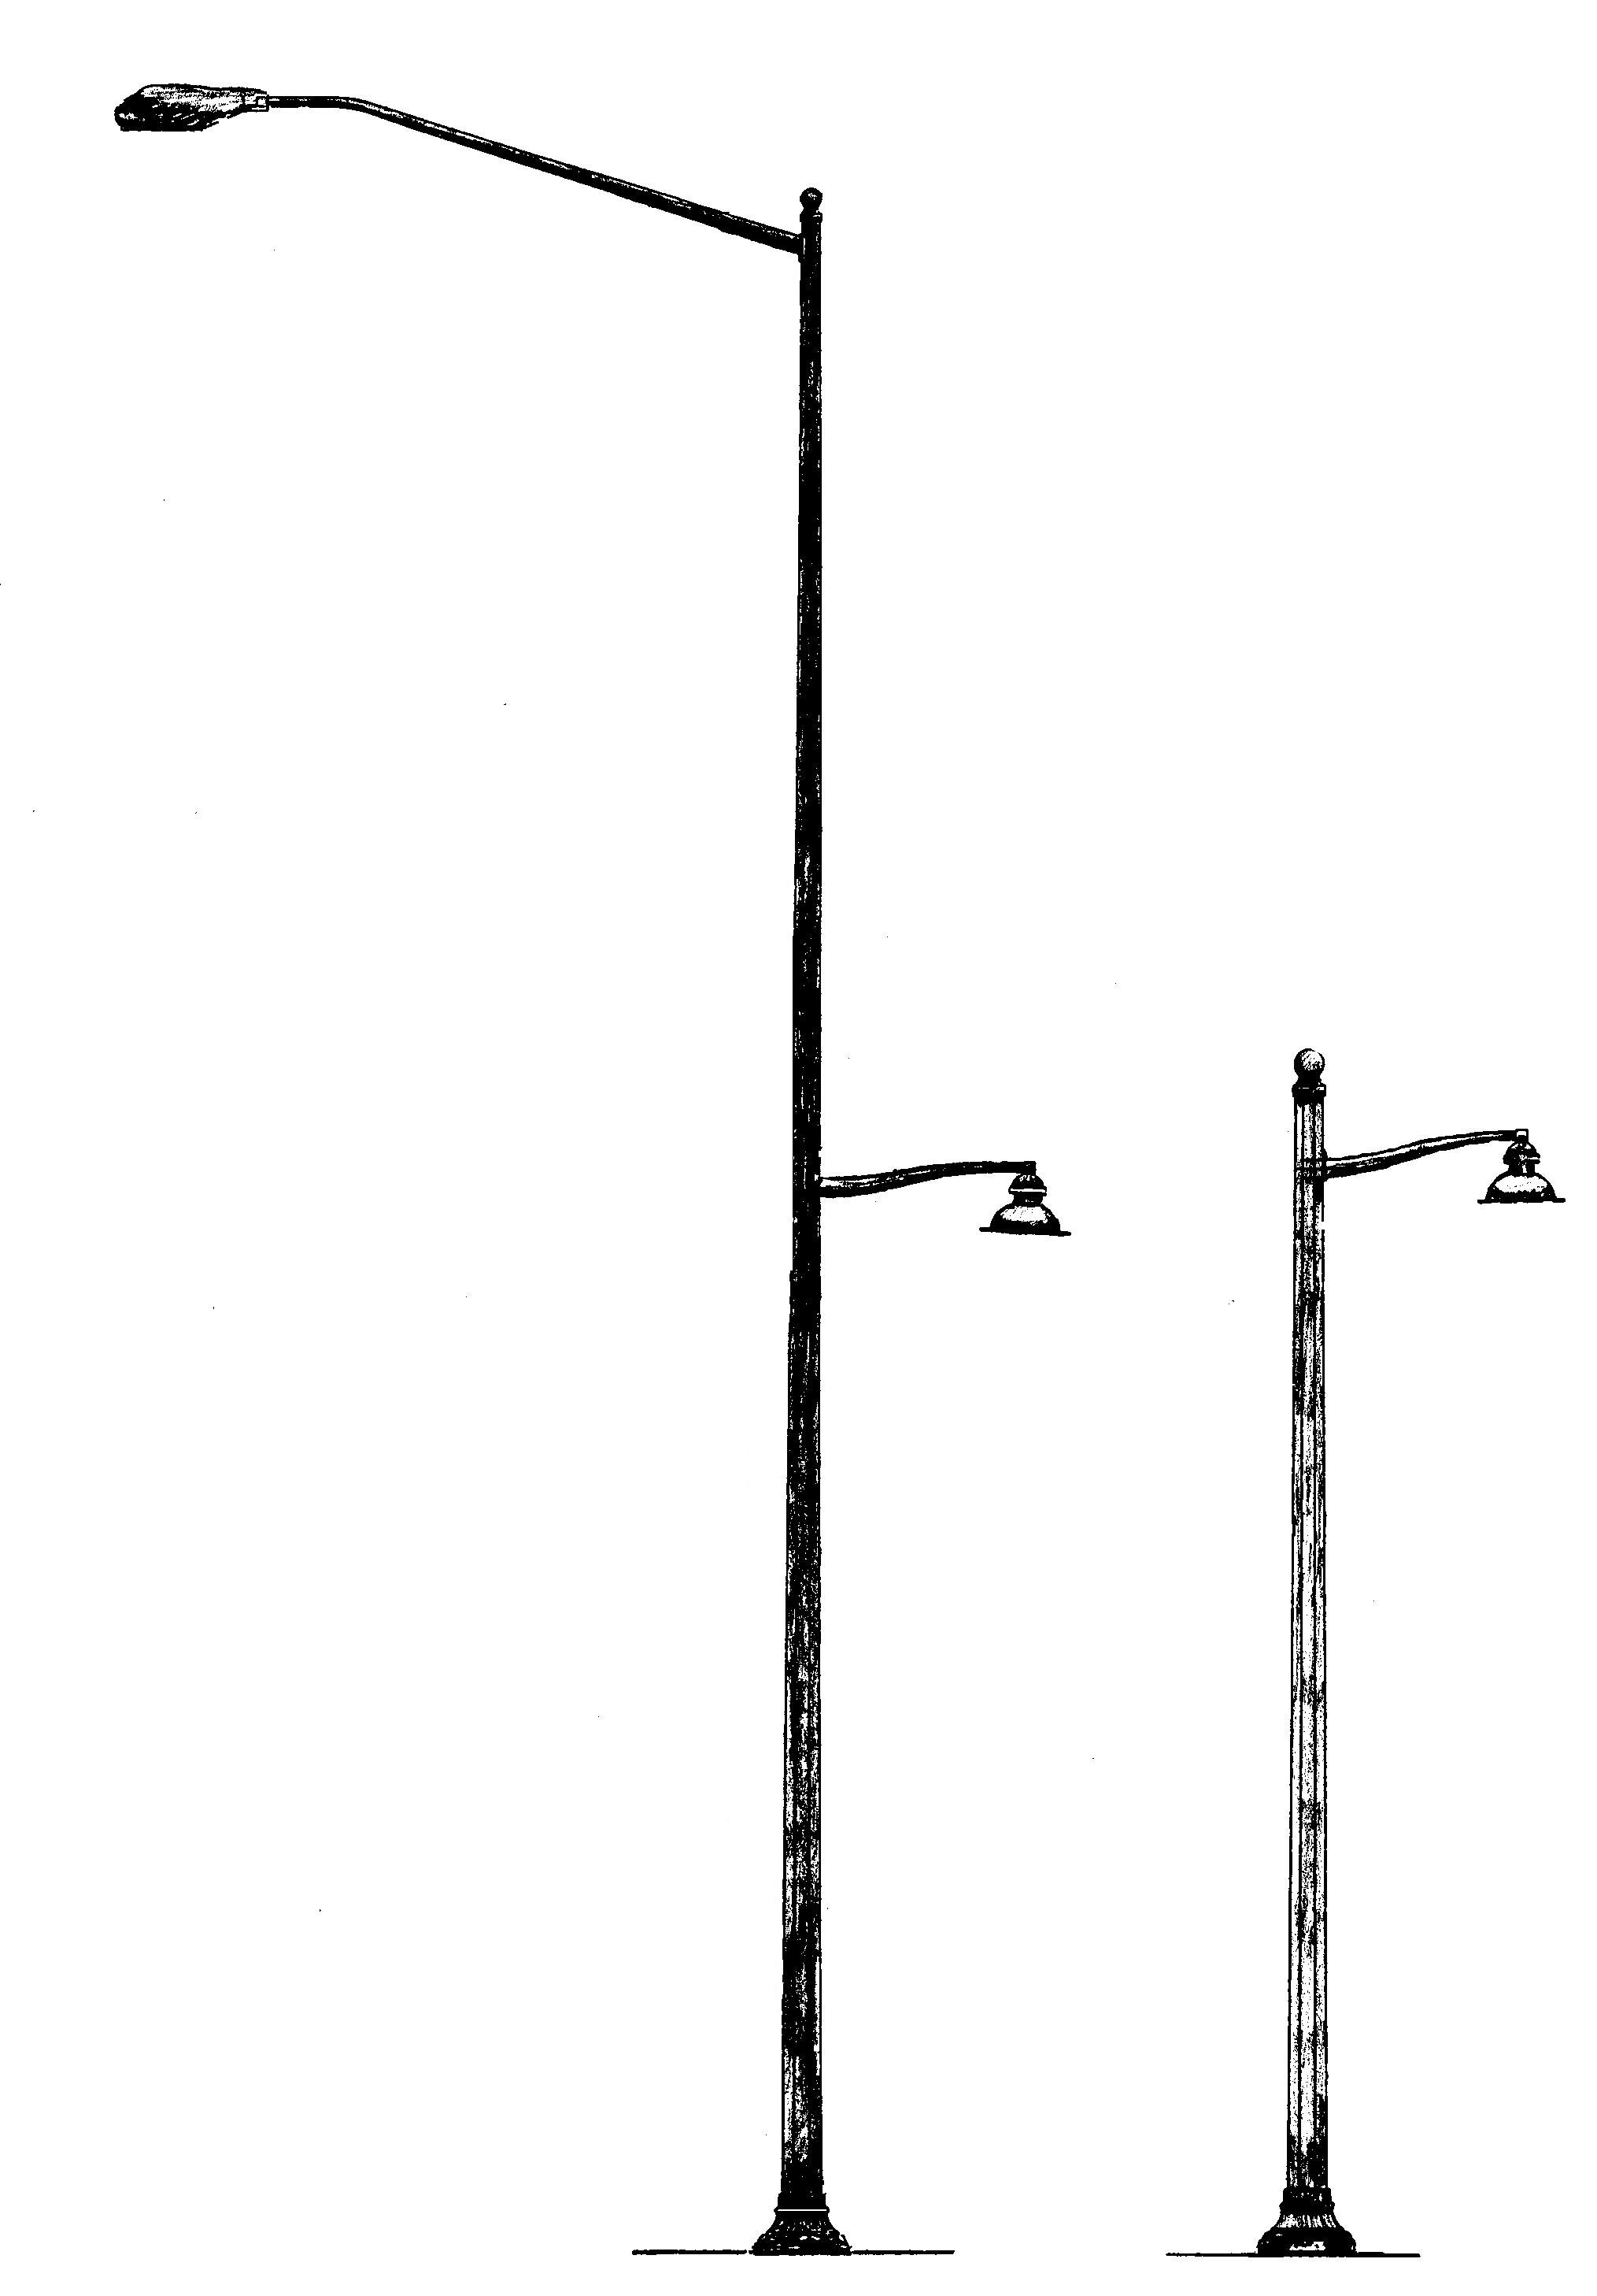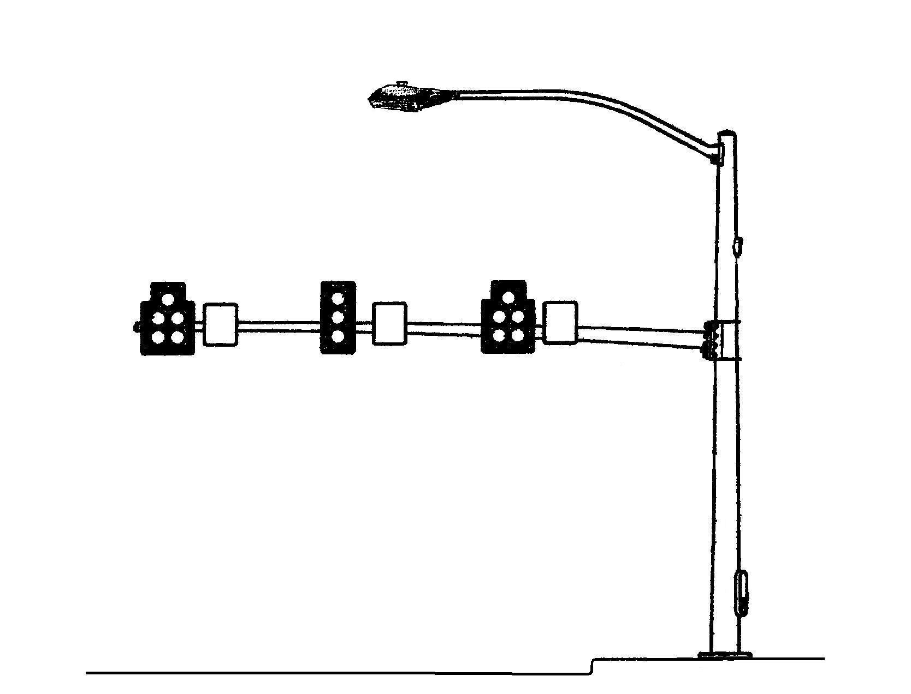
Streetlight and Pedestrian Light Typical Mast Arm Traffic Signal Pole

The design of the proposed street and pedestrian lights include downward facing light fixtures mounted at 15’ above the sidewalk to provide pedestrian level lighting. These fixtures are installed approximately 80’ apart and provide a significantly more uniform level of sidewalk lighting than is currently provided by the more widely spaced streetlights alone. Their lower mounting height also minimizes shaded areas that can result from tree limbs, canopies and other obstructions and their downward facing design reduces glare and light pollution. We believe the uniform lighting level these pedestrian level fixtures provide, increases pedestrian safety while providing a comfortable ambience to the Downtown. In the last three years the Town has installed these fixtures in several Downtown locations and they have been very well received by affected merchants and others. The design of the mast arm poles includes dark green tapered metal poles selected to compliment the appearance of the tapered metal streetlight poles. Although not shown in the small illustration above, these mast arm poles will also include pedestrian activated crosswalk signals.

Attachments 2 - 4 include detailed descriptions and cost estimates of each of the three proposed projects. Attachment 3 also includes a conceptual plan of the sidewalk reconstruction project.

Recommended Project 1: Install mast arm traffic signal poles and upgrade the crosswalks on Franklin Street at the intersections of Columbia Street (four poles and crosswalks) and Porthole Alley (two poles, one crosswalk), at an estimated cost of $230,000 (Attachment 2) .

Recommended Project 2: Construct Streetscape improvements in a 700-foot section of sidewalk on the south side of the 100 and 200 blocks of West Franklin Street adjacent to University Square at an estimated cost of $240,000 (Attachment 3). The attachment includes a discussion of issues related to the proposed curb realignment, which would provide additional area behind the curb for a wide sidewalk and associated pedestrian amenities but would reduce the width of the current wide outside lane on this block of Franklin Street.

Recommended Project 3: Install custom lighting where Streetscape has otherwise been completed on the south side of the 500 and 600 blocks of West Franklin Street from Roberson Street to Merritt Mill Road at an estimated cost of $60,000 (Attachment 4). These lighting improvements would complete the Streetscape project in this area.

RECOMMENDATION

We recommend that the Council approve the attached resolutions a, b and c authorizing the Town Manager to proceed with downtown lighting, traffic signal and Streetscape improvements as described in this report.

ATTACHMENTS

- Map showing Streetscape construction and lighting improvements completed to date (p. 7).
- Recommended Project 1 – description for improvements to the traffic signal poles and crosswalks on Franklin Street at the intersections of Columbia Street and Porthole Alley (p. 8).
3. Recommended Project 2 – description and conceptual plan of Streetscape improvements on the south side of the 100 and 200 blocks of West Franklin Street adjacent to University Square (p. 10).
- Recommended Project 3 - description of lighting improvements on the south side of the 500 and 600 blocks of West Franklin Street from Roberson Street to Merritt Mill Road (p. 13).
RESOLUTION A

A RESOLUTION AUTHORIZING THE TOWN MANAGER TO Submit a Specialty Lighting Request to Duke Power Company for the installation of four mast arm traffic signal poles at the intersection of Franklin and Columbia Streets and two mast arm signal poles at the intersection of East Franklin Street and Porthole Alley, to upgrade crosswalks at those intersections, and to utilize $230,000 in 2003 sidewalk bond funds for the improvements (2005-04-25/R-9a)

WHEREAS, the Council adopted the Downtown Streetscape Master Plan as part of the Town’s Comprehensive Plan; and

WHEREAS, lighting and signal system improvements are a fundamental part of the Town’s Downtown Streetscape Master Plan; and

WHEREAS, $230,000 currently exists in bond funding to implement a portion of the Streetscape Master Plan; and

WHEREAS, the Council has received a report from the Town Manager describing plans for lighting and traffic signal improvements as well as a plan for sidewalk construction;

NOW, THEREFORE, BE IT RESOLVED by the Council of the Town of Chapel Hill that the Council authorizes the Town Manager to submit a Specialty Lighting Request to Duke Power Company for the installation of four mast arm traffic signal poles at the intersection of Franklin and Columbia Streets and two mast arm signal poles at the intersection of East Franklin Street and Porthole Alley, to upgrade crosswalks at those intersections, and to utilize $230,000 in 2003 sidewalk bond funds for the improvements.

This the 25th day of April, 2005.

RESOLUTION B

A RESOLUTION AUTHORIZING THE TOWN MANAGER TO Develop working drawings for Streetscape improvements on the south side of the 100 and 200 blocks of West Franklin Street adjacent to University Square, discuss plans with property owners and merchants, utilize $240,000 of the 2003 Streetscape bond funds, and begin construction in May 2005 (2005-04-25/R-9b)

WHEREAS, the Council adopted the Downtown Streetscape Master Plan as part of the Town’s Comprehensive Plan; and

WHEREAS, $240,000 currently exists in bond funding to implement a portion of the Streetscape Master Plan; and

WHEREAS, the Council has received a report from the Town Manager describing plans for lighting and traffic signal improvements as well as a plan for Streetscape construction to begin May 2005; and

WHEREAS, Town labor resources are available for construction of the improvements;

NOW, THEREFORE, BE IT RESOLVED by the Council of the Town of Chapel Hill that the Council authorizes the Town Manager to develop working drawings for Streetscape improvements on the south side of the 100 and 200 blocks of West Franklin Street adjacent to University Square, discuss plans with property owners and merchants, utilize $240,000 of the 2003 Streetscape bond funds, and begin construction in May 2005.

This the 25th day of April, 2005.
RESOLUTION C

A RESOLUTION AUTHORIZING THE TOWN MANAGER TO Submit a Specialty Lighting Request to Duke Power Company for the installation of custom street and pedestrian lighting on the south side of the 500 and 600 blocks of West Franklin Street where other Streetscape improvements have already been completed and to Utilize $60,000 in bond funds for the lighting improvements (2005-04-25/R-9c)

WHEREAS, the Council adopted the Downtown Streetscape Master Plan as part of the Town’s Comprehensive Plan; and

WHEREAS, lighting improvements are a fundamental part of the Town’s Downtown Streetscape Master Plan; and

WHEREAS, $60,000 currently exists in bond funding to implement a portion of the Streetscape Master Plan; and

WHEREAS, the Council has received a report from the Town Manager describing plans for lighting and traffic signal improvements as well as a plan for Streetscape construction;

NOW, THEREFORE, BE IT RESOLVED by the Council of the Town of Chapel Hill that the Council authorizes the Town Manager to submit a Specialty Lighting Request to Duke Power Company for approximately $60,000, for the proposed lighting improvements.

This the 25th day of April, 2005.

