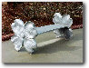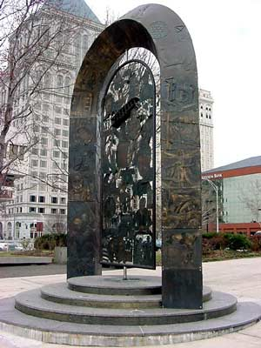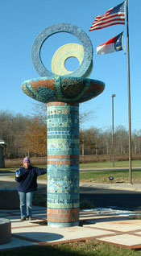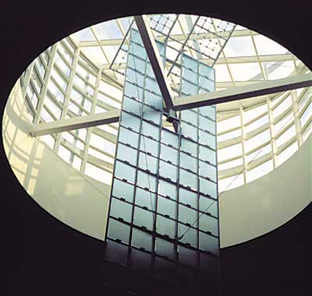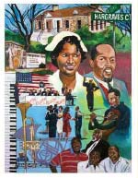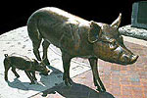

North Carolina Public Art Network
Chapel Hill Public Arts Commission
Durham Arts Council
Invite you to join us for

The Public Art Process: A Workshop for Artists

Saturday, May 21, 2005 • 9:30 a.m. – 4:00 p.m.

Durham Arts Council
120 Morris Street, Durham, NC

$10.00 registration fee (includes lunch and workshop materials)

Over the last two years, North Carolina municipalities and organizations advertised and held competitions for more than $5 million in public art commissions. Did you compete?

Join us and learn from experienced artists and public art administrators how to:

• Make the leap from the studio to public art
• Understand and interact with a community
• Collaborate with engineers, architects, other artist, et al
• Address project problems and find solutions
• Manage proposals, contracts, budgets and other nuts & bolts public art stuff

This workshop will provide valuable information for all artists, arts administrators, designers, architects, and other creative types!

Workshop presenters:
Larry Kirkland – Washington DC based public artist with over 200 completed public art projects

Jean Greer – Vice President for Public Art, Arts & Science Council, Charlotte
Kathy Triplett – Asheville area ceramic artist with recent public art experience
Janet Kagan – Board Member, Chapel Hill Public Arts Commission
Kate Flory – Executive Director, Chapel Hill Public Arts Commission
Jeffrey York – Director of Public Art & Community Design, North Carolina Arts Council

Optional: Artists are invited to bring samples of their artwork (slides, CD) for individual advice on making the leap to public art. (Please bring no more than ten images.)

Pre-registration is requested. To register, please complete the attached form and:
Email: jeffrey.york@ncmail.net • Fax: 919.733.4834 • Call: 919.715.0834

For directions to the Durham Arts Council and parking instructions go to www.durhamarts.org/facility_directions.html

This program is sponsored by the North Carolina Public Art Network, a service of the North Carolina Arts Council, the Chapel Hill Public Arts Commission, and the Durham Arts Council

The Public Art Process: A Workshop for Artists

Saturday, May 21, 2005 • 9:30 a.m. – 4:00 p.m.

Durham Arts Council
120 Morris Street, Durham, NC

Registration Form

Pre-registration is requested. To register, please complete this form and:
Email: jeffrey.york@ncmail.net • Fax: 919.733.4834 • Call: 919.715.0834

Please register me for the public art seminar in Durham on May 21, 2005. (A separate registration form is required for each participant. Please feel free to duplicate this form for each guest.)

NOTE: A $10.00 registration fee, which includes lunch and workshop materials, will be collected when you arrive at the workshop. Please bring cash or check only. Credit cards will not be accepted.

Name ________________________________________________________________

Address _______________________________________________________________

______________________________________________________________________

City ____________________________________ State _______ Zip ______________

Phone ______________________________________Fax ______________________

Email Address __________________________________________________________

____ Yes, I plan to bring samples of my artwork (slides or CD) for individual advice on making the leap to public art. (Please bring no more than ten images.)

My level of experience with public art commissions is: (circle one)

High Medium Low None

This program is sponsored by the North Carolina Public Art Network, a service of the North Carolina Arts Council, the Chapel Hill Public Arts Commission, and the Durham Arts Council

